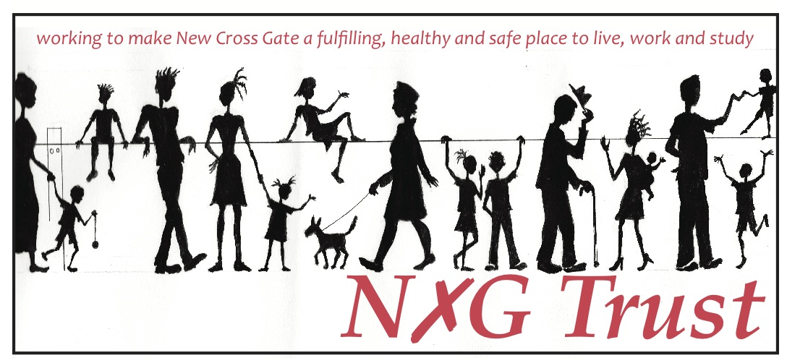

Health & Safety Policy

(including lone working)

Date agreed: April 2017

Date for review: April 2020

This is the Health and Safety Policy Statement of The New Cross Gate Trust and covers the workplace at:

Besson Street Community Garden Besson St, SE14 5AE.

1. Policy Aims
The New Cross Gate Trust is committed to:
- Providing a safe working environment for employees, trustees, volunteers, and those accessing the Trust’s facilities, services and equipment, including visitors, service users and contractors;
- Effectively delivering quality services in a way that contributes to improving health and safety awareness;
- Providing adequate control of the health and safety risks arising from our activities;
- Consulting with our employees, trustees, volunteers, and those accessing the Trust’s facilities, services and equipment on matters affecting their health and safety, and taking remedial action as appropriate;
- Providing and maintaining safe plant and equipment, and ensuring safe handling and use of substances;
- Providing information, instruction and supervision for employees in order to promote health and safety awareness;
- Ensuring all employees are competent in performing their tasks, and to give them adequate training;
- Applying best practice in order to prevent accidents and cases of work-related ill health;
- Maintaining safe and healthy working conditions;
- Reviewing and revising this policy as necessary at regular intervals (and at least once every three years).

Signed: _________________

Chair of the Trust
Effective: April 2017

2. Policy Implementation
The Trust’s Health and Safety policy will be delivered by:
  - Developing and implementing this Health and Safety policy and related guidance;
  - Providing advice, information and support to staff;
  - Carrying out audits, inspections and monitoring to ensure appropriate levels of health and safety management, and to ensure that laws are not broken;
  - Providing accredited Health and Safety training courses;
  - Undertaking accident and incident monitoring and preventative support;
  - Seeking to continually improve the Health and Safety culture of the Trust;
  - Promoting well being at work;
  - Providing training and support on moving and handling people or goods; and
  - Ensuring the Trust operates in accordance with the Health and Safety at Work Act 1974 and all applicable regulations made under the Act, as far as reasonably practicable, together with other relevant legislation such as the Control of Substances Hazardous to Health (COSHH) Regulations 2002 and the Health and Safety (Display Screen Equipment) Regulations 1992.

3. Responsibilities

- Overall and final responsibility for health and safety is that of:
Chair of the Trust

- Day-to-day responsibility for ensuring this policy is put into practice is delegated to:
Strategy and Partnerships Manager

- Day to day health and safety of users of the premises; and
- Training and advising sessional staff, volunteers and users of the relevant health and safety policies and procedures is the responsibility of:
Besson Street and Community Development Manager

All employees have to:
- co-operate on health and safety matters;
- not interfere with anything provided to safeguard their health and safety;
- take reasonable care of their own health and safety and that of others e.g. fellow employees; and
- report all health and safety concerns to an appropriate person (as detailed elsewhere in this policy.)

4. Health and safety risks arising from our work activities

4.1 General risks

An annual general risk assessment will be undertaken by:
Strategy and Partnerships Manager

The findings of the general risk assessment will be reported to:
Chair and Board of Trustees

Action required to remove/control risks will be approved by:
Board of Trustees

Responsibility for ensuring the action required is implemented rests with:
Chair

Checking that the implemented actions have removed/reduced the risks will be done by:
Strategy and Partnerships Manager

This general risk assessment will be reviewed annually or whenever the Trust’s work activities or services undergo substantial change, whichever is soonest.

4.2 Fire risk assessment

An annual fire risk assessment will be undertaken by:
Strategy and Partnerships Manager

The findings of the fire risk assessment will be reported to:
Finance and General Purposes Committee

Action required to remove/control risks will be approved by:
Board of Trustees

Responsibility for ensuring the action required is implemented rests with:
Chair

Checking that the implemented actions have removed/reduced the risks will be done by:
Strategy and Partnerships Manager

This fire risk assessment will be reviewed annually or whenever the Trust’s work activities or services undergo substantial change, whichever is soonest.

5. Consultation with employees

The Strategy and Partnerships Manager will undertake consultation with other permanent and sessional staff to identify any possible health and safety risks, and take appropriate action as a result.

6. Information, instruction and supervision

The Health and Safety Law poster is displayed in:
Lobby of Brick Building

Health and safety advice is available from:
Strategy and Partnerships Manager

7. Competency for tasks and training

Training will be identified, arranged and monitored by:
The Strategy and Partnerships Manager

Induction training will be provided for all employees by:
Strategy and Partnerships Manager / Besson Street and Community Development Manager as appropriate

Job specific training will be provided by:
Strategy and Partnerships Manager / Besson Street and Community Development Manager as appropriate

Fire Warden Training has been undertaken by:
Strategy and Partnerships Manager / Besson Street and Community Development Manager
This training will be offered to all staff.

Training records are kept by:
Strategy and Partnerships Manager

Training records are kept:
In staff files

8. Accidents, first aid and work-related ill health

The first aid box(es) and eye first aid kits is/are kept:
Main lobby and kitchen of Brick Building

The appointed first aider(s) is/are:
Besson Street and Community Development Manager

All accidents and cases of work-related ill health are to be recorded in the accident book.

The book is kept by:
Besson Street and Community Development Manager

The book is kept:
Lobby of Brick Building

The responsibility for reporting accidents, diseases and dangerous occurrences to the enforcing authority rests with:
Besson Street and Community Development Manager

9. Monitoring

To check our working conditions, and ensure our safe working practices are being followed, we will do the following:

- Annual review by the Board of the health and safety risk register
- Annual consultation with staff and sessional staff covering prospective hazards and knowledge of the health and safety policy
- Training of new staff in health and safety

10. Investigations
The responsibility for investigating accidents rests with:
Strategy and Partnerships Manager
The responsibility for investigating work-related causes of sickness absences rests with:
Chair
The responsibility for acting on investigation findings to prevent a recurrence rests with:
Strategy and Partnerships Manager or Chair as appropriate.

10. Emergency procedures: fire and evacuation

Escape routes are:
Front Door. Out main gate and wait in pedestrianised area of Besson St.

Responsibility for checking these routes daily rests with:
Besson Street and Community Development Manager

Responsibility for undertaking evacuation in the event of a fire:
The Strategy and Partnerships Manager and/or Besson Street Centre Manager.

Fire extinguishers are located:
Kitchen and Lobby of Brick Building

Fire extinguishers are maintained and checked annually by:

Fire Safety Services (UK) Limited,
Progress House, 15 Railton Road,
Woburn Road Industrial Estate, Kempston, Bedford,
MK42 7PW
Tel: 01234 854100

All electrical appliances are also PAT tested annually.

Smoke alarm is in the Kitchen of Brick Building.

Responsibility for testing the alarm monthly rests with:
Strategy and Partnership Manager

11. Lone Working Policy

Policy Statement
The Trust is committed to ensuring a healthy and safe working environment for its staff. This includes ensuring effective management of the risks associated with individual members of staff working on their own. As the staff of the Trust will sometimes work alone, it is essential that they remain safe.

Scope/Definition of Lone Working
A lone worker is any staff member, including volunteers, working alone in a building, including their home, or in the community.

Implementation
The safety of staff is of paramount importance. The Trust will ensure that:
  - Risk Assessments are undertaken for lone working which determine and prioritise actions and resources to minimise identified lone working hazards. These will be reviewed annually by the Finance and General Purposes Committee
  - Procedures are in place and safe systems of work introduced which incorporate appropriate support systems.
  - Advice and guidance is provided to all staff covering personal safety and security considerations in respect of lone working.
  - Equipment is made available to enable staff to work safely alone, including (for example) mobile phones and personal attack alarms, as appropriate, if identified as a need in risk assessments.
  - Training will be made available addressing the issues associated with lone working.

Staff responsibilities

All staff must:
  - Read and have copies of this policy and supporting information, including the outcomes of risk assessments;
  - Ensure they participate in the undertaking of risk assessments and their annual review;
  - Adhere to systems, policies and procedures developed for their protection while working alone;
  - Take personal responsibility for sharing information regarding their whereabouts;
  - Inform line management of any concerns regarding lone working;
  - Report and record lone working incidents to enable systems to be reviewed and revised (including RIDDOR reports) as appropriate.

Risk Assessment
Risk Assessments are to be completed by the Strategy and Partnerships Manager and reviewed annually at the start of April. Each new employee will be made aware of all policy documents and asked to read through the Risk Assessments folder.
For any new work task or change of working practise a new or updated Risk Assessment is required.
Risk assessments will be carried out for all staff engaged in lone working, which will include consideration of:
  - Hazards within the workplace or place to be visited;
  - Methods of communication;
  - The provision of equipment such as mobile phones or personal attack alarms;
  - “Buddy” working in pairs when problems are anticipated;
  - Possibility of violence;
  - Risks to men/women working alone;
  - Risks to young people;
  - Medical fitness of the person working alone, including the possibility of sudden illness;
  - Possibility of accidents, including consideration of the specific activities taking place
  - Requirements for first aid training;
  - Provision of supervision/advice; and
  - Method of alarm raising in the event of loss of contact.

Links to other policy documents:

Staff Handbook
Disciplinary Procedures
Grievance policy and procedures

We will continue to review this policy through an annual consultation with staff and reviews of our health and safety policies and procedures, alongside regular reviews of the overall Trust Risk Register.

